MINI BUG REPORT FOR PERSONAL PROJECTS
@CREATIVITY THINK (9483175986/7019689991)

ABSTRACT:
Mini Bug Report for Personal Projects is a lightweight web-based bug tracking system designed for individual developers and students working on mini or personal-level projects. It enables users to manage bugs project-wise with essential features such as priority, status updates, comments, and history tracking. Built using Django REST Framework and React, the application provides a simple, clean, and efficient interface to track and update bugs, improving productivity and debugging efficiency for solo developers..

INTRODUCTION OF THE PROJECT:
When working on personal or academic projects, developers often struggle to track bugs systematically. Most enterprise bug tracking systems are overly complex for small-scale development. The Mini Bug Report system solves this by providing an easy-to-use bug board where users can create projects, add bugs, set priorities, track status changes, and maintain history logs. The application’s simplicity makes it ideal for mini projects, prototypes, or personal codebases where quick bug management is essential..

PROJECT OBJECTIVES:

• Provide a simple and effective bug tracking system for personal and mini projects
• Allow users to create and manage multiple projects
• Add bug details including title, description, priority, and current status
• Enable status transitions like Open → In Progress → Fixed
• Maintain history of updates and comments for each bug
• Provide filtering options for completed or closed bugs
• Build a fast and responsive UI using React
• Offer backend reliability through Django REST Framework

PROBLEM OF THE STATEMENT:
Students and solo developers usually lack a structured tool to track bugs in small-scale projects. Manual tracking through notes or spreadsheets leads to confusion, poor organization, and loss of data. There is a need for a simple, efficient, and accessible bug reporting tool that does not require enterprise-level complexity. The Mini Bug Report system addresses this by providing an easy-to-manage bug tracker tailored for personal development needs..

MOTIVATION OF THE PROJECT:
• To help developers maintain organized bug lists for personal or academic projects
• To avoid confusion caused by manual or inconsistent tracking methods
• To provide a minimal but powerful alternative to heavy tools like Jira or Bugzilla
• To offer quick filtering and status updates for better debugging workflow
• To support productivity by maintaining history and comments
• To create a system that is simple, fast, and easy to use daily

BLOCK DAIGRAM OF PROJECT:

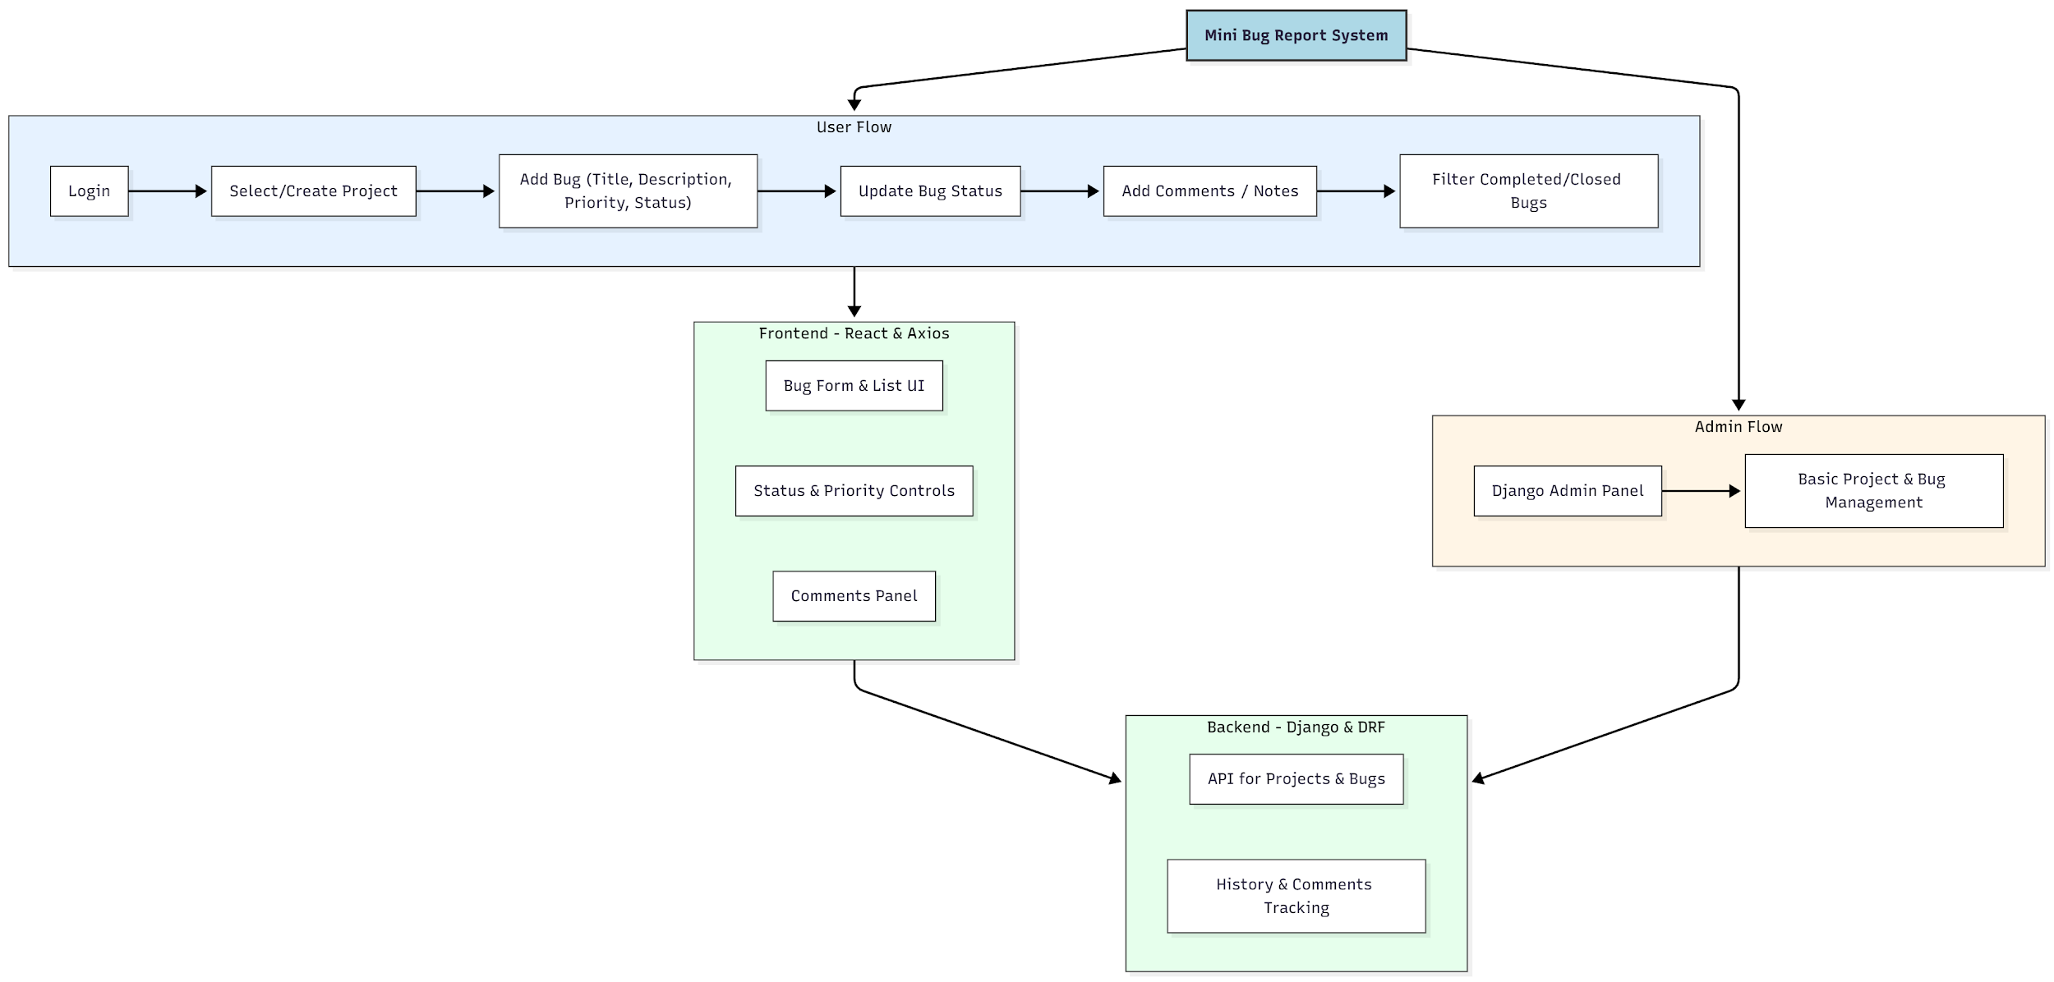

WORKING OF THE PROJECT:
The user logs into the system and begins by creating or selecting a project. Within each project, bugs can be added by specifying title, description, priority level, and status. The React frontend interacts with Django REST API endpoints to store and retrieve bug details. Users can update the bug’s status as it progresses from Open to In Progress to Fixed. They can also add comments or notes for each bug, which are saved for history tracking. The system provides filtering options to display only completed or open bugs. The admin uses Django’s built-in admin panel for basic management without requiring a separate dashboard..

SOFTWARE REQUIREMENT:
- Backend:
  - Python 3.x
  - Django
  - Django REST Framework
  - SQLite/PostgreSQL
- Frontend:
  - Node.js and npm
  - React.js
  - Axios
- Development Tools:
  - Visual Studio Code
  - Postman (for testing APIs)
  - Git/GitHub (for version control)
- Server/Deployment (Optional):
  - Gunicorn, Nginx, or Heroku/AWS for hosting

ADVANTAGES OF THE PROJECT:

• Simple and user-friendly interface
• Fast bug management suitable for mini/personal projects
• Organized tracking of bugs with comments and history
• Easy project-wise segregation of issues
• Lightweight compared to industry-level bug tools
• Quick updates and filtering to improve workflow
• Secure login and API-based backend

APPLICATIONS OF THE PROJECT:
• Personal mini projects
• Student academic projects
• Individual developer prototypes
• Solo programming debugging tasks
• Small project issue tracking
• Simple test or QA practice boards

REFERENCES:

- Django REST Framework Documentation — Django Software Foundation. Django Documentation. Available: https://docs.djangoproject.com/
- Django REST Framework. DRF Documentation. Available: https://www.django-rest-framework.org/
- React. React Official Documentation. Available: https://reactjs.org/docs/getting-started.html
- Redux. Redux Documentation. Available: https://redux.js.org/introduction/getting-started
- PostgreSQL Global Development Group. PostgreSQL Documentation. Available: https://www.postgresql.org/docs/
- MySQL. MySQL Reference Manual. Available: https://dev.mysql.com/doc/
- Git. Git Documentation. Available: https://git-scm.com/doc
- Node.js. Node.js Documentation. Available: https://nodejs.org/en/docs/
- Axios. Axios Documentation. Available: https://axios-http.com/docs/intro
- Socket.io Documentation – https://socket.io/docs/

